**HOME ASSIGNMENT -2**

**OBJECTIVE: To develop a Personal Portfolio Website with Secure Login Functionality.**

**In this project, I designed and built a fully responsive portfolio website that showcases my skills as a software developer. The website is crafted using HTML, CSS, JavaScript, and Java, focusing on delivering a clean, professional interface accessible across various devices, including desktops, tablets, and mobile phones. Additionally, a secure login system enables multiple users to view their personalized portfolio pages.**

**Languages and Tools Used:**

**- HTML: Structured the content and layout of the website.**

**- CSS: Styled the site to create a visually appealing and cohesive design that aligns with the portfolio theme.**

**- JavaScript: Implemented interactivity, dynamic content display, and smooth navigation throughout the site.**

**- Responsive Design: Ensured the site adjusts seamlessly across different devices, providing an optimal viewing experience.**

**- Login Functionality: Developed a secure login page to authenticate users and display their personalized portfolios.**

**- Active Projects Showcase: Featured key projects, including the Fitness Tracker App, in a dedicated section for easy access.**

**Applications of My Work:**

**This portfolio serves as a digital representation of my skills in software development and web design. It demonstrates my capability to create functional, aesthetic, and interactive web applications, which can be adapted to various real-world use cases, such as personal websites, corporate portfolios, or software documentation.**

**Website Overview:**

1. **Login Page**

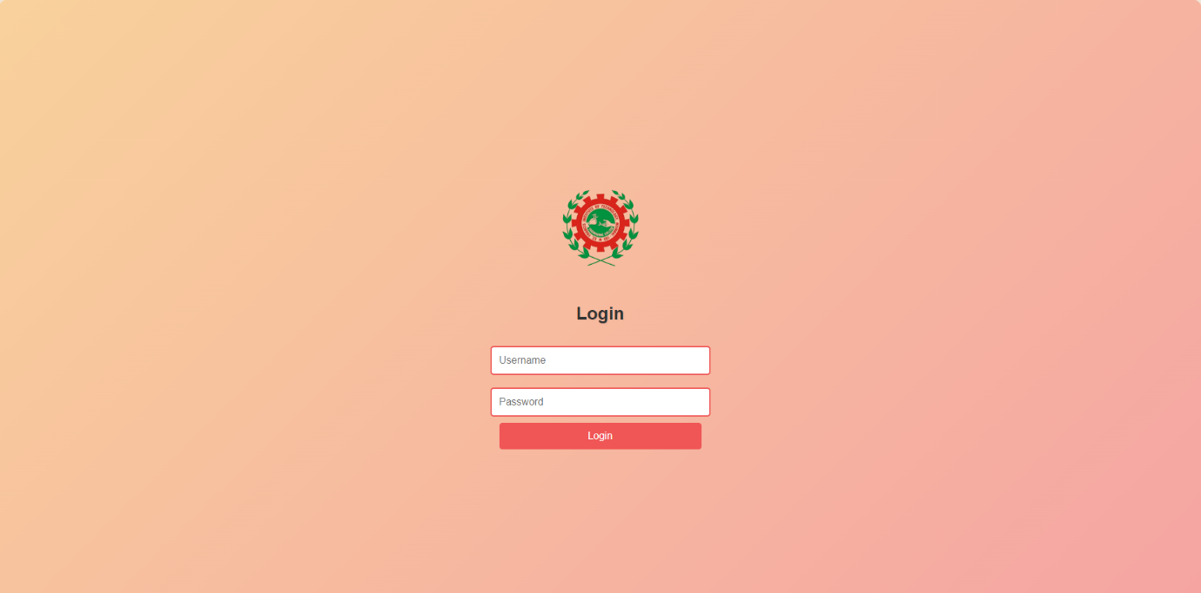

**Before accessing the portfolio, users encounter a secure login page designed for authentication. Multiple users can log in with unique credentials to access their own personalized portfolio pages. The login page is styled to match the overall theme, with the college logo centered for a professional touch.**

1. **Home Page**

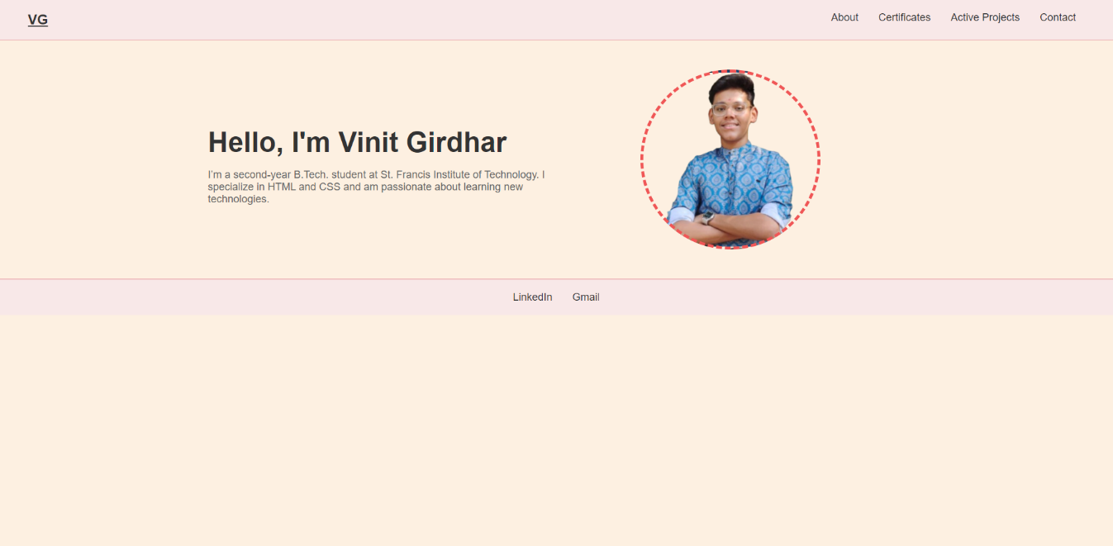

**The landing page features a welcoming introduction, offering a seamless navigation experience with an "Explore My Work" button that directs visitors to the Active Projects section.**

1. **About Page**

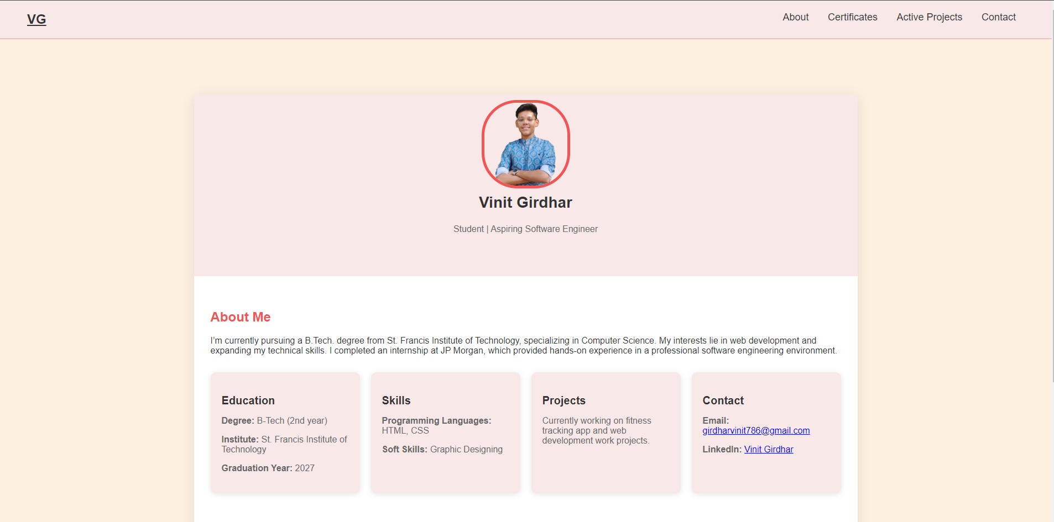

**This section highlights my background, including education and technical skills, providing insights into my qualifications and areas of expertise.**

1. **Active Projects Section**

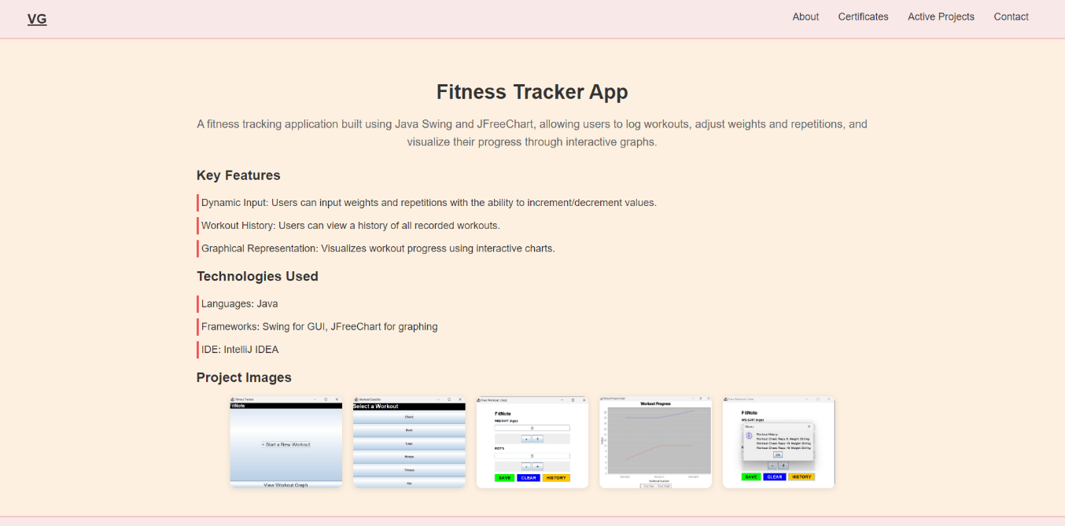

**A dedicated area where key projects, such as the Fitness Tracker App, are showcased. Each project is accompanied by a description and relevant images to give visitors a visual representation of my work.**

1. **Contact Page**

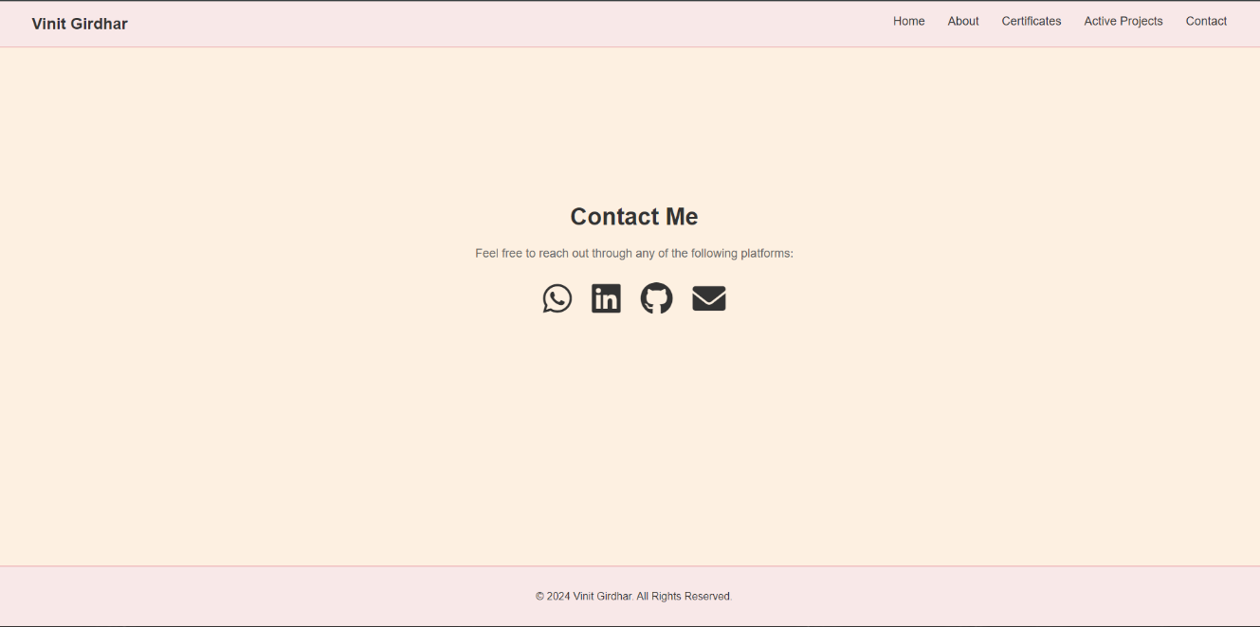

**A contact page featuring mascot icons linked to my social profiles (WhatsApp, LinkedIn, GitHub, Gmail), allowing visitors to connect with me easily.**

1. **Certificates Showcase**

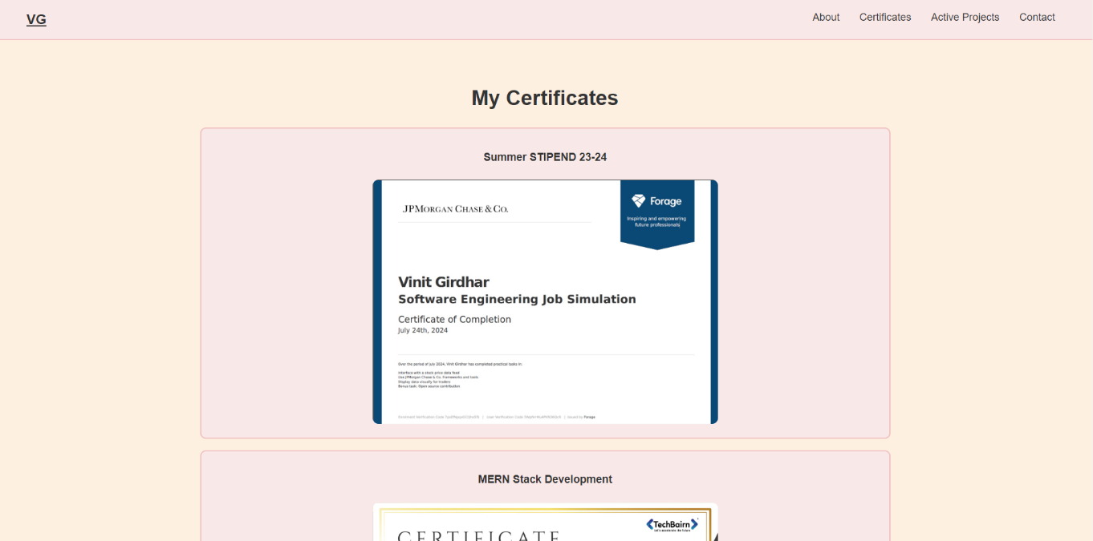

**Conclusion:**

**The project successfully delivered a responsive and interactive portfolio website that highlights my expertise in web development and programming. The integration of secure login functionality provides a personalized user experience, while the Fitness Tracker App showcases my skills in creating engaging software.**

**Plans for future enhancements include adding a blog to share updates and insights, incorporating server-side functionality for improved data management, and introducing animation effects to elevate the overall user experience.**